Margaret Beaufort Institute of Theology.
Online Liturgy –Thursday February 10th 2022 6.00pm
Saint Scholastica, Virgin
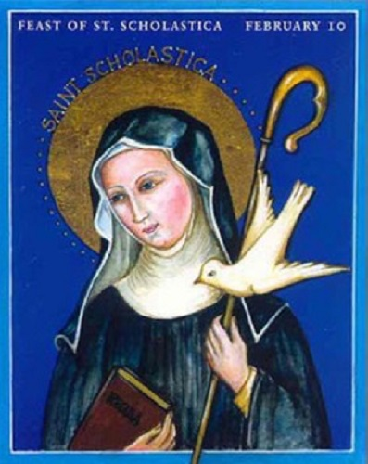
“I ASKED YOU AND YOU WOULD NOT LISTEN; SO I ASKED MY GOD AND HE DID LISTEN.” Saint Scholastica
Saint Scholastica [+c543] was the sister of Saint Benedict. She followed the rule of her brother near Montecassino and is regarded as the first Benedictine nun. When she met her brother for the last time, a sudden rainstorm providentially prolonged the meeting; three days later St Benedict saw her soul ascend to heaven as a dove [her symbol in art]

We begin with a stilling exercise – led by Jackie Tevlin

Today’s Gospel Reading
A reading from the holy Gospel according to Luke 10: 38-42
Martha welcomed him into her house. Mary had chosen the better part.
In the course of their journey Jesus came to a village, and a woman named Martha welcomed him into her house. She had a sister called Mary, who sat down at the Lord’s feet and listened to him speaking. Now Martha, who was distracted with all the serving said, “Lord, do you not care that my sister is leaving me to do the serving all by myself? Please tell her to help me.” But the Lord answered: “Martha, Martha,” he said, “you worry and fret about so many things, and yet few are needed, indeed only one. It is Mary, who has chosen the better part; it is not to be taken from her.”
The Gospel of the Lord
A time of silence
You are invited to turn off your screen and spend the next few minutes reflecting on the scripture passage. You may like to look for words or phrases that resonate, words that you haven’t noticed before. Allow yourself to be aware of the impact that they have on you. They may indicate what the reading is pointing towards for you.
Sharing
We will come back together on screen and then move into breakout rooms for a short time of sharing. Each room will be led by a facilitator. You are invited to share your thoughts, without comments from anyone else. There may be time for further reflections.
Everyone will then come back together to close with prayer.
PRAYER TO SAINT SCHOLASTICA
O God,
to show us where innocence leads,
you made the soul of your virgin Saint Scholastica
soar to heaven like a dove in flight.
Grant through her merits
and her prayers
that we may so live in innocence
as to attain to joys everlasting.
This we ask through our Lord. Amen
St Emma’s Benedictine Monastery U.S.A.

CLOSING PRAYER

