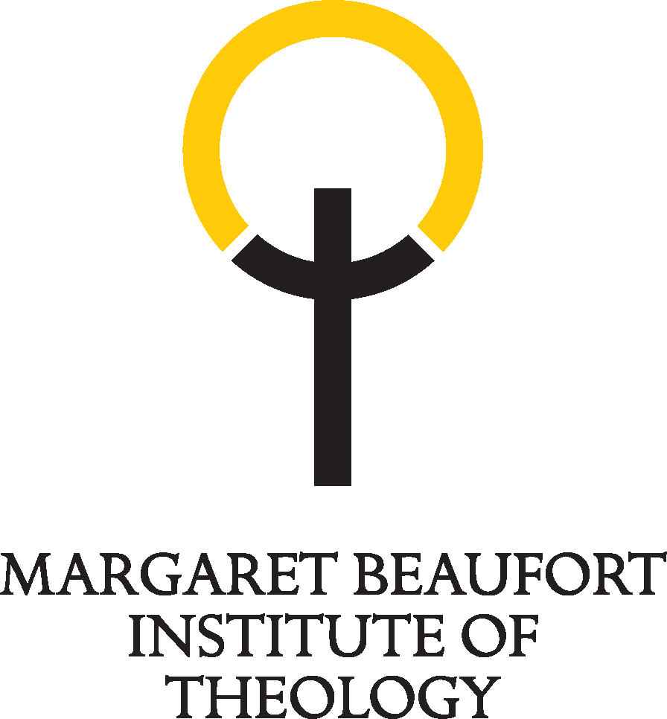

Margaret Beaufort Institute of Theology
Notes for Bursaries at MBI for 2025-26 entry
The Institute has the following types of student bursary for 2025 entry:
- One ‘Educators’ Bursary (50% for 2 years PT study) for an MA student working in Education
- One ‘Chaplaincy’ Bursary (50% for 2 years PT study) for an MA student with a Chaplaincy role
- Postgraduate and short course bursaries funded through a grant from the Canonesses of St Augustine
- MBI bursaries for postgraduate, undergraduate, short courses or study days
Value of Bursaries
It is the Institute’s policy to retain flexibility about the value of bursaries in order to respond to the needs of an individual student, and to make best use of the funding available in each of the bursary funds.
Term of Bursaries
We consider the whole of a student’s course in allocating our bursaries. This ensures that students on longer courses have their need for funding throughout the duration of their study considered from the outset.
After the first year, each case will be reviewed annually providing the required form and information is submitted each year. As long as academic requirements are met to a satisfactory level and outstanding fees are paid, then normally those on two- or three- year courses can have certainty of funding during the entire course of studies.
Use of Bursary Funding
Bursary funding may be applied to the payment of fees and/or student maintenance and in some cases other costs. Each case is considered individually.
Eligibility
- All applicants must be students at (or have applied to) the Margaret Beaufort Institute of Theology, studying for an undergraduate or postgraduate degree at either Anglia Ruskin University or University of Cambridge, or another MBIT course. Research applicants may also be considered.
- The main criterion for the selection of eligible students is financial need. This means that applicants must be willing to divulge their financial situation, both income and expected expenditure.
- They must also be able to show that they have exhausted other avenues for funding, including the advice they will be given by the Institute about other sources of funding.
- In making a decision, household earnings are taken into account which normally include earnings from employment, job seekers allowance, employment & support allowance, pension, working tax credits, child tax credits, other regular income. This does not include: housing benefit, child benefit, disability living allowance or personal independence payments.
- Full and part-time students are eligible for bursary funding
- Applications may come from students living anywhere in the world.
- Students may apply at any stage of their course of studies, provided they apply before the cut-off point(s) in any particular year.
- Applications will also be considered in line with (a) MBIT’s founding purpose, (b) mission, (c) values/operational beliefs and (d) the strategic goals and priorities as expressed in the MBI Strategy.
Timing of Applications and Decisions
Applications for funding should be made after the normal admissions process has been completed and a place has been offered. During the admissions process, applicants will indicate any intention to apply for a bursary to the Director of Studies who will advise them on the application process, including the completion of these documents:

- MBI SCHOLARSHIPS BURSARIES APPLICATION FORM 2025-26 ENTRY

- A REFERENCE (NEW STUDENT) OR PROGRESS REPORT (CURRENT STUDENT)

- A COVERING LETTER (FOR NEW STUDENTS).

New students intending to make an application for bursary funding should complete the admissions process as early as possible in the academic year. There will be three rounds of bursary applications for the 2025-26 academic year: applications in round 1 must be received on or before Sunday 5th January 2025; and no later than Sunday 29 June 2025 (first summer round) or Sunday 31 August 2025 (second summer round). Any applications made later than the notified dates will not normally be considered.
Students in the second or third years of their programme whose financial situation has changed and are applying for a bursary for the first time should also generally apply in round 2 or round 3 in 2025, as should students who received a bursary in 2024-25 who would like to apply for continued funding.
We encourage you to discuss your situation with the Director of Studies as soon as possible.
Conditions of Bursaries
- Prospective students who have been awarded a bursary will be expected to show a firm commitment to taking up their place at the Institute.
- Continuing students must have successfully completed all the requirements of the year before a bursary can be renewed. They should also have paid all outstanding bills to the Institute and/or Cambridge Theological Federation, University of Cambridge or Anglia Ruskin University.
- The Bursary Panel will determine whether a student receives a bursary. Students in receipt of bursaries from the Canonesses of St Augustine will be expected to provide a brief profile of themselves, using a proforma that can be shared with the donors of their bursaries. They will also be asked to provide a short personal reflection at the end of their course of study.
- Those receiving a bursary commit to participating in the academic life of the Institute, e.g. research seminars, events.
Bursary Panel
The Panel comprises members of the Academic team, chaired by the Principal and the Director of Finance.
Appeals against decisions of the Bursary Panel
The decision of the Panel is final and there is no appeals procedure.
Updated 13 May 2025.

